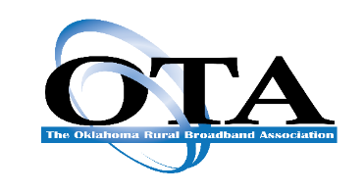

To: OTA Associate Members

From: Tom Karalis

Executive Vice President

It’s time again to register for our 2024 OTA Accounting Conference, which will be held on November 7th and 8th at the OKC Downtown Sheraton in Oklahoma City.

The General Sessions will include several speakers from State and National organizations and representatives from our own Member Companies, touching on the latest Financial & Accounting issues, including a Washington, DC update.

**Conference highlights**

* Two days of topics, with the opportunity for interactive Q&A with Presenters
* CPE credits for attendees
* Interaction with your peers throughout the Conference including a Welcome Reception on Thursday night.

A block of rooms at the OKC Downtown Sheraton in Oklahoma City has been contracted at $139 per night. **The cut-off date to receive the group rate is Oct 16th** Make your reservations by clicking on the Hotel link below:

[**Book your group rate for Oklahoma Telephone Association Accounting Conference**](https://www.marriott.com/events/start.mi?id=1719579079088&key=GRP)

**2024 OTA ACCOUNTING CONFERENCE**

**ITINERARY**

**Thursday, November 7th, 2024**

**Noon** Luncheon

**12:50 pm** TK’s Welcome and Opening Remarks

**1:00 pm** OCC Update – Ron Comingdeer, Comingdeer & Murer & Bill Bullard, WBFB Law

**1:45 pm** EA-CAM Requirements – Jennifer Blaine, JSI

**2:15 pm** Industry / NECA Updates – Teri Kessler, NECA

**3:00 pm 30min Networking Break**

**3:30 pm** Liability Insurance Coverage & Preparedness, Dustin Brown, TIG

Surviving a Tornado – The Story of Chickasaw Telephone, Larry Jones, Chickasaw Telephone Company

**4:30 pm** Tax & Accounting Updates – Jason Oelrich & Tracey Welcher, Eide Bailly

**5:15 pm** RUS Updates – Shekinah Pepper, RUS, & Adam Anderson, OK GFR

**6:00 pm** Welcome Reception

**Friday, November 8th, 2024**

**7:30 am** Breakfast

**8:30 am** TK’s Welcome and Opening Remarks

**8:45 am** Washington DC Updates – Eric Keber, WTA

**9:30 am** NG911 & FCC Order – Lance Terry, OK E911

**10:15 am 30 min Networking Break**

**10:45 am** USF Court Case Implications – Jonathan Spalter, USTelecom via Zoom

**11:30 am** Oklahoma ARPA Grants Update – OK BB Office

**Thank You – End of Conference**

You may register online or complete this registration form and email it directly to me at [tom@oklata.org](mailto:tom@oklata.org). If you have any questions or need further information, please do not hesitate to contact me at 405.525.7700 (Office) or 918.636.1313 (Cell).

I look forward to seeing everyone again!

Tom Karalis

EVP – The Oklahoma Rural Broadband Association

OKLAHOMA TELEPHONE ASSOCIATION

2024 OTA Accounting Conference Registration

**Sheraton OKC Downtown Hotel**

**Century Center Parking Garage, 1 N Broadway Ave, Oklahoma City,**

**Phone:** [**(405) 235-2780**](https://www.google.com/search?client=firefox-b-1-d&q=sheraton+okc+downtown)

### Company: ______________________________________________

**Phone: ______________________________________________**

**Associate Member Registration Fee: $175 per person**

**Non-Member Registration Fee: $225 per person**

**Name of Attendee/s:**

1. **_____________________________________________________________________**
2. **_____________________________________________________________________**
3. **_____________________________________________________________________**
4. **_____________________________________________________________________**
5. **_____________________________________________________________________**

**OTA ACCOUNTING CONFERENCE**

**Sponsorship Levels**

**Your sponsorship is greatly appreciated for the 2024 Accounting Conference. The levels of sponsorship are as follows:**

**Platinum Sponsors $ 1,000**

**Emerald Sponsor $750**

**Gold Sponsor $500**

**Silver Sponsor $250**

**Bronze Sponsor $150**

**Please return this form along with your credit card authorization or check made payable to:**

**Oklahoma Telephone Association**

**3800 N. Classen Blvd, Suite 215**

**Oklahoma City, OK 73118**

**Telephone: (405) 525-7700**

**THANK YOU FOR SUPPORTING THE**

**OKLAHOMA TELEPHONE ASSOCIATION**

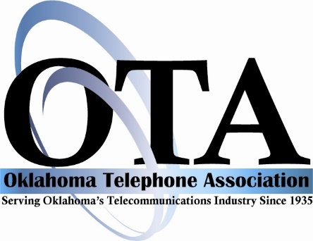

**BILLING AUTHORIZATION FORM**

I authorize you to charge my bill directly to the credit card listed below:

Company Name:_____________________________________________________

Card # ________________________________________________________

Exp. Date: _________

Print Cardholder’s Name: ______________________________________________

Billing Address: ______________________________________________________

City: __________________________________ State:____________ Zip_________

Phone: ____________________________

Amount to be billed:

Registration (s): $ _______________________

Sponsorship(s): $ _______________________

**TOTAL: $ _______________________**